## A-1 Assembly

### A-1.1 Trailrider components

The Trailrider assembly consist of the following components:

* Front fork assembly with integrated castor wheel
* Main frame
* Two quick-release rear wheels
* Two propulsion levers
* Footplate
* Padded seat cushion

### A-1.2 Attaching rear wheels

The wheels are designed to be quick-release, so this process should not take long in attaching the wheels to the frame. Due to the time constraints of this project, we were not able to design in detail the quick clip-on mechanism to attach the wheels to the frame.

### A-1.3 Attaching front fork

To attach the front fork to the main frame, perform the following steps:

1. Loosen the screw with a 5mm allen key, provided in the assembly. Take off all components labelled in the figure below, except for the bottom bearing.
2. Slide the fork through the tube attached to the frame
3. Place back all components on top of the fork in the reverse order that they were taken off.
4. Tighten screw with the allen key until snug.

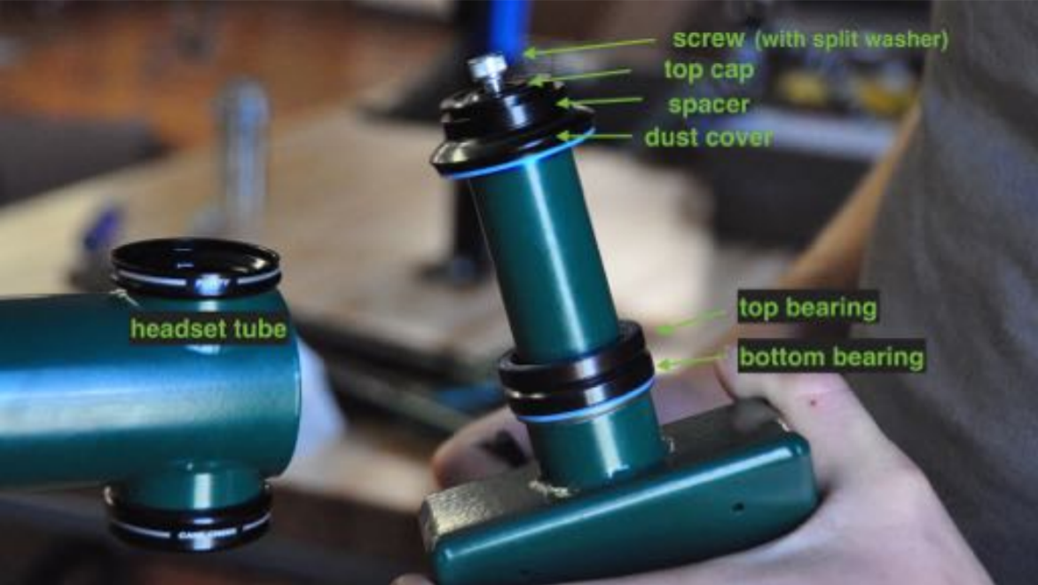

Figure 1: GRIT chair front fork-to-frame attachment parts

### A-1.4 Attaching foot plate

To attach the foot rest to the frame, perform the following steps:

1. Loosen the clamp attached to the bottom vertical tube of the frame
2. Insert the footplate tube into the clamp
3. Tighten the fixture by pressing the clamp handle down so it is parallel with the tube.

### A-1.5 Attaching seat cushion

To attach the seat cushion to the frame, simply attach the velcros from the cushion to the frame.

## A-2 Riding

### A-2.1 Safety

It is crucial that you practice safe maneuvers on the Trailrider in a safe, flat area until you get the hang of it. Do not attempt to maneuver through steep slopes and rough terrain until you are 100% confident in your handling abilities.

To ensure you safety at all times while riding, please make sure that you:

1. Wear a proper helmet
2. Maintain proper position at all times by using appropriate straps attached to the footplate and seat

### A-2.2 Adjustability

**Seat Angle**

You can adjust your seat angle position by pressing on the buttons in the lever between the seat and handlebars. Slide the lever to the desired slot and allow the button to slide through the slot to ensure it is secure.

**Footplate Height**

You can adjust the height of the footplate by releasing the clamp and sliding the tube up or down to desired height. Ensure you secure the clamp after adjusting.

### A-2.3 Using lever drivetrain

In order to use the levers, first you need to attach them to the drivetrain:

1. Ensure that they are rotated so that the braking lever is facing outwards.
2. Insert each lever into the coupling attached to the driving sprocket on either end of the seat. You should hear a click as the pins in the lever reach the end of the slots.

**Propulsion**

To propel yourself forward, push forward on the levers. Pull backwards to reset the lever position, and repeat this process again.

**Braking**

To brake, pull the levers all the way back so that the braking lever engages with the tire and stops rotation.

**Turning**

In order to turn left, push the right lever forward and keep the left lever stationary.

To turn right, push the left lever forward and keep the right lever stationary.

### A-2.4 Climbing and descending slopes

Climbing and descending slopes is a tricky maneuver, but with the help of the long levers, you are able to adjust the “gear ratio” of the Trailrider by adjusting where you grip on the levers. In short, gear ratios determine how easy or hard it is for you to propel forwards.

**Climbing**

1. Adjust your grip to hold closer to the top of the levers, and propel forwards as usual.
2. Bend you torso forwards to transfer more weight to the front of the Trailrider, in order to keep it balanced.

**Descending**

1. Lean your torso back into the seat to keep the Trailrider balanced.
2. Ensure you make proper use of the brakes by pulling all the way back on the levers.
3. Try to descend in shorter interval so that the Sherpa doesn’t overheat the disc brakes. Travelling in zig zags is also better than going straight down.

**Flat ground**

If you are strong, adjust your grip lower on the levers to go faster but with extra effort. Otherwise, keep your grip in the middle/top of the levers.

### A-2.5 Transfers

1. Before transferring, ensure that the parking brake is engaged and theTrailrider is completely stationary.
2. To enter in or out of the Trailrider, prop your torso up by holding onto the frame beside the seat.
3. Swing one leg over the fork and step onto the ground with both legs. If this is not possible, have someone assist in doing so. Please note that it is also possible to use the traditional BCMOS method of transferring riders through the use of a crane.

## A-3 Disassembly

### A-3.1 Removing seat cushion

To remove the seat cushion, simply pull it off from the velcros on the frame.

### A-3.2 Removing foot plate

1. Release the clamp attaching the foot plate to the frame.
2. Pull out the foot plate bar from the clamp.

### A-3.3 Removing front fork

Please see section 1.3 of this user manual. Perform the same steps, with the only difference being that you are removing the fork from the frame instead of attaching it. Ensure you put all components (screw, bushings, spacer, etc) back onto the frame and tighten the screw to prevent your from losing them.

### A-3.4 Removing rear wheels

The wheels are designed to be quick-release, so this process should not take long in de-attaching the wheels from the frame. Due to the time constraints of this project, we were not able to design in detail the quick clip-on mechanism to de-attach the wheels from the frame.

## A-4 Maintenance

### A-4.1 Inflating wheels

The tire pressure should be checked regularly to reduce the risk of damage and reduce the rolling resistance of the tires. The tires should be inflated to **35 psi.**

### A-4.2 Chain lubrication and cleaning

You should lubricate both chains once a month with synthetic oil or similar (can be found at a bike shop). This is easily done by simultaneously driving the chain by spinning the wheel, and dropping oil onto the chain links. To avoid a big mess, place a rag under the drivetrain.

### A-4.3 Chain inspection and replacement

During the lifetime of this product, the chain will require replacement once it becomes too worn out after excessive use. You should check for chain wear every three months using a chain gauge. You should also check once a month that the tension in the chain is sufficient. To learn more about chain wear, tension and when to seek a chain replacement, please visit the following website:

<http://www.bike-manual.com/brands/trek/om/trailerbike/chain.htm>

If you find that you require a chain replacement, please visit a bike shop as this process requires special tools.

### A-4.4 Changing gear ratio

If you would like to mechanically change your drivetrain gear ratio (say if you want to make it easier or harder overall to propel), it is possible to do so by selecting a different cog on the rear cassette to have the chain run on. This will require taking off the chain and putting it back on the selected cog of choice, which means you will need to visit a bike shop.

## 

## A-5 Warnings

Please be advised of the following warnings in order to ensure your safety:

1. Ensure that all pin connections are secured properly (i.e. the pin ‘clicks’ when it is secure).
2. Ensure all clamps and screws are tightened properly.
3. Practice riding the TrialRider in a safe, flat area until you are proficient at propulsion, turning and braking. You do not want to end up in a situation where you can injure yourself by not knowing how to maneuver on a hill!
4. Ensure that you are properly secured into the wheelchair. Failure to do so could cause you to fall out of the chair.

The following warnings address some of the highest RPN issues determined in DFMEA:

1. To reduce risk of tires popping, ensure that your tires are always inflated to the correct pressure. Ensure that your inner tubes are in good condition too.
2. To reduce risk of chain breaking, ensure you follow the chain maintenance procedures outlined in section 4.0.

**Reference for Figure 1:**

<https://static1.squarespace.com/static/54a1bb27e4b07419f3973e5e/t/5894e2df17bffc8959c58dde/1486152422134/FC+user+manual+2.5.pdf>